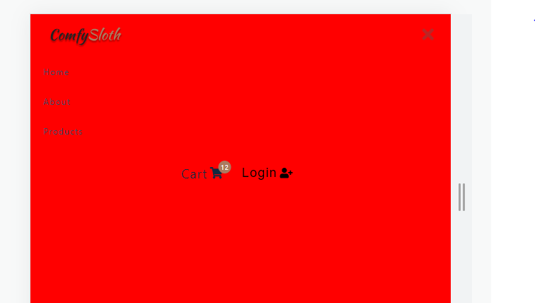

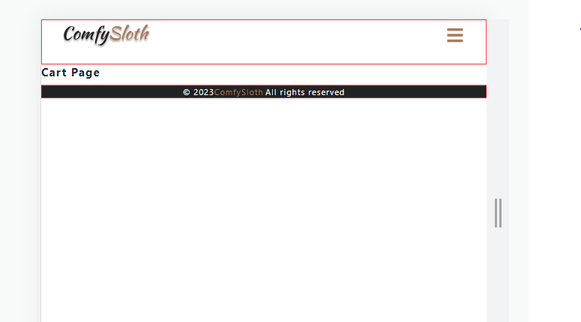

Initially false. When we click on 3 line the show x and when we click on x show 3 line

import React from 'react'

import styled from 'styled-components'

import logo from '../assets/logo.svg'

import { FaBars } from 'react-icons/fa'

import { Link } from 'react-router-dom'

import { links } from '../utils/constants'

import CartButtons from './CartButtons'

import { useProductsContext } from '../context/products_context'

import { useUserContext } from '../context/user_context'

const Nav = () => {

  const {openSidebar} = useProductsContext();

  return (

    <NavContainer>

      <div className="nav-center">

        <div className="nav-header">

          <Link>

            <img src={logo} alt="" />

          </Link>

          <button type="button" className="nav-toggle" onClick={openSidebar}>

            <FaBars />

          </button>

        </div>

        <ul className="nav-links">

          {links.map((link) => {

            const { id, text, url } = link

            return (

              <li key={id}>

                <Link to={url}>{text}</Link>

              </li>

            )

          })}

        </ul>

        <CartButtons />

      </div>

    </NavContainer>

  )

}

const NavContainer = styled.nav`

  border: 1px solid red;

  height: 5rem;

  display: flex;

  align-item: center;

  justify-content: center;

  .nav-center {

    width: 90vw;

    margin: 0 auto;

    max-width: var(--max-width);

  }

  .nav-header {

    display: flex;

    align-items: center;

    justify-content: space-between;

  }

  img {

    width: 175px;

    margin-left: -15px;

  }

  .nav-toggle {

    background: transparent;

    border: transparent;

    color: var(--clr-primary-5);

    cursor: pointer;

    svg {

      font-size: 2rem;

    }

  }

  .nav-links {

    display: none;

  }

  .cart-btn-wrapper {

    display: none;

  }

  @media (min-width: 992px) {

    .nav-toggle {

      display: none;

    }

    .nav-center {

      display: grid;

      grid-template-columns: auto 1fr auto;

      align-items: center;

    }

    .nav-links {

      display: flex;

      justify-content: center;

      li {

        margin: 0 0.5rem;

      }

      a {

        color: var(--clr-grey-3);

        font-size: 1rem;

        text-transform: capitalize;

        letter-spacing: var(--spacing);

        padding: 0.5rem;

        &:hover {

          border-bottom: 2px solid var(--clr-primary-7);

        }

      }

    }

    .cart-btn-wrapper {

      display: grid;

    }

  }

`

export default Nav

import React from 'react'

import logo from '../assets/logo.svg'

import { Link } from 'react-router-dom'

import { useProductsContext } from '../context/products_context'

import { FaTimes } from 'react-icons/fa'

import { links } from '../utils/constants'

import styled from 'styled-components'

import CartButtons from './CartButtons'

const Sidebar = () => {

  const {isSidebarOpen, closeSidebar} = useProductsContext();

  return (

    <SidebarContainer>

        <aside className={`${isSidebarOpen ? 'sidebar show-sidebar' : 'sidebar'}`}>

          <div className='sidebar-header'>

              <img src={logo} alt="comfy sloth" className='logo'/>

              <button type='button' className='close-btn' onClick={closeSidebar}>

                <FaTimes />

              </button>

          </div>

          <ul className='links'>

            {

                links.map(({id,text,url})=>{

                   return(

                    <li key={id}>

                      <Link to={url} onClick={closeSidebar}>{text}</Link>

                    </li>

                   )

                })

            }

          </ul>

          <CartButtons />

        </aside>

    </SidebarContainer>

  )

}

const SidebarContainer = styled.div`

 text-align:center;

 .sidebar-header{

    border:1px solid red;

    display:flex;

    justify-content:space-between;

    align-items:center;

    padding:1rem 1.5rem;

 }

 .close-btn{

  font-size:2rem;

  background:transparent;

  border-color:transparent;

  color:var(--clr-primary-5);

  transition:var(--transition);

  cursor:pointer;

  color:var(--clr-red-dark);

  margin-top:0.2rem;

 }

 .logo{

  justify-self:center;

  height:45px;

 }

 .links{

  margin-bottom:2rem;

 }

 .links a{

    text-align:left;

    display:block;

    font-size:1rem;

    text-transform:capitalize;

    padding:1rem 1.5rem;

    color:var(--clr-grey-3);

    transition:var(--transition);

    letter-spacing:var(--spacing);

 }

 .links a:hover{

  padding:1rem 1.5rem;

  padding-left:2rem;

  background:var(--clr-grey-10);

  color:var(--clr-grey-2);

 }

 .sidebar{

  position:fixed;

  top:0;

  left:0;

  width:100%;

  height:100%;

  background:var(--clr-white);

  background-color:red;

  transition:var(--transition);

  transform:translate(-100%);

  z-index:-1;

 }

 .show-sidebar{

  transform:translate(0);

  z-index:999;

 }

 .cart-btn-wrapper{

  margin:2rem auto;

 }

 @media screen and (min-width:992px){

  .sidebar{

    display:none;

  }

 }

`

export default Sidebar

products_context.js:---------------------------------------------------------

import axios from "axios";

import React, { useContext, useEffect, useReducer } from "react";

import reducer from "../reducers/products_reducer";

import { products_url as url } from "../utils/constants";

import {

  SIDEBAR_OPEN,

  SIDEBAR_CLOSE,

} from "../actions";

const initialState = {

  isSidebarOpen: false,

};

const ProductsContext = React.createContext();

export const ProductsProvider = ({ children }) => {

  const [state, dispatch] = useReducer(reducer, initialState);

  console.log(state);

  const openSidebar = () => {

    dispatch({ type: SIDEBAR_OPEN });

  };

  const closeSidebar = () => {

    dispatch({ type: SIDEBAR_CLOSE });

  };

  return (

    <ProductsContext.Provider value={{ ...state, openSidebar, closeSidebar }}>

      {children}

    </ProductsContext.Provider>

  );

};

// make sure use

export const useProductsContext = () => {

  return useContext(ProductsContext);

};

Products_reducer.js:------------------------------------------------------

import {

  SIDEBAR_OPEN,

  SIDEBAR_CLOSE,

} from '../actions'

const products_reducer = (state, action) => {

  if(action.type === SIDEBAR_OPEN){

    console.log(action);

    return{...state, isSidebarOpen:true}

  }

  if(action.type === SIDEBAR_CLOSE){

    return{...state, isSidebarOpen:false}

  }

  return state

  throw new Error(`No Matching "${action.type}" - action type`)

}

export default products_reducer

index.jsx:------------------------------

import React from "react";

import ReactDOM from "react-dom/client";

import "./index.css";

import App from "./App";

import { ProductsProvider } from "./context/products_context";

const root = ReactDOM.createRoot(document.getElementById("root"));

root.render(

  <ProductsProvider>

    <App />

  </ProductsProvider>

);

